**Auto Scaling (10th September 2024)**

**Create a Launch Template –**

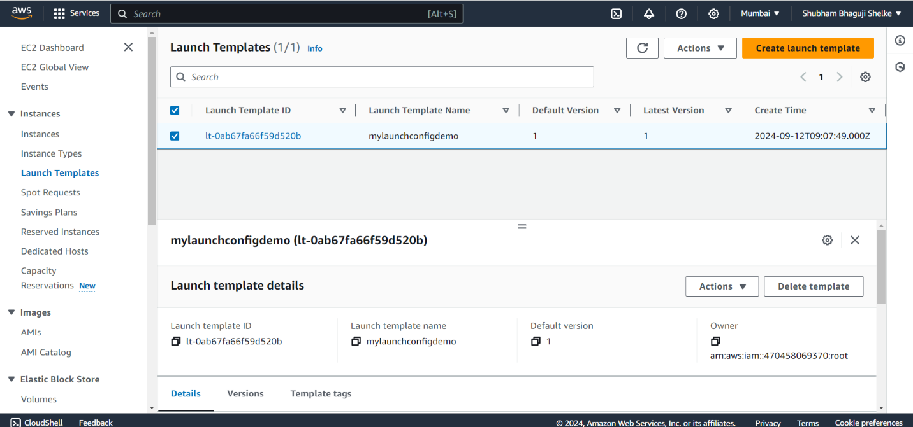

**Create a Auto Scaling group –**

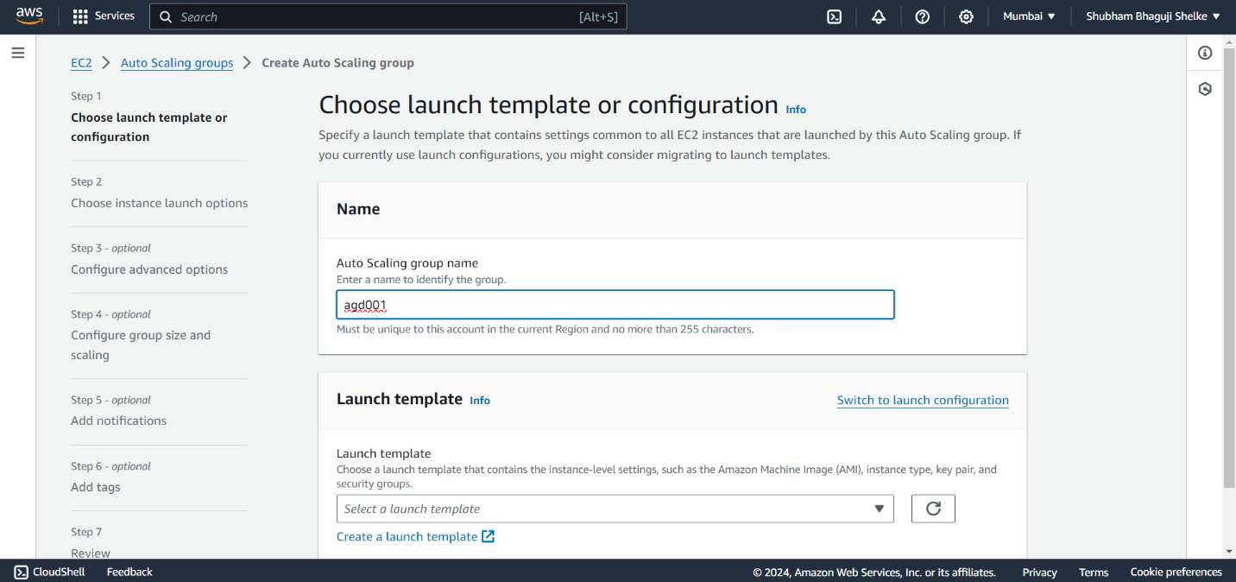

**Select Availability zone & Subnets (ap-south-1a&ap-south-1b)**

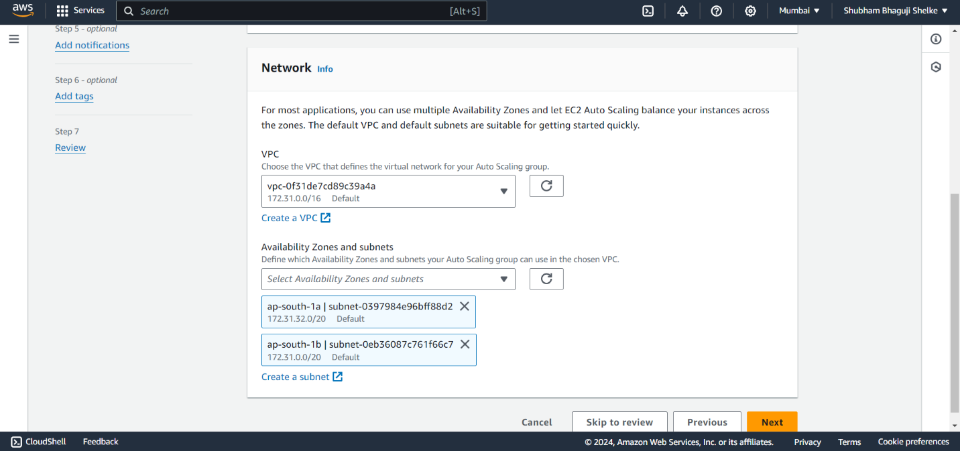

**Configure group size and scaling**

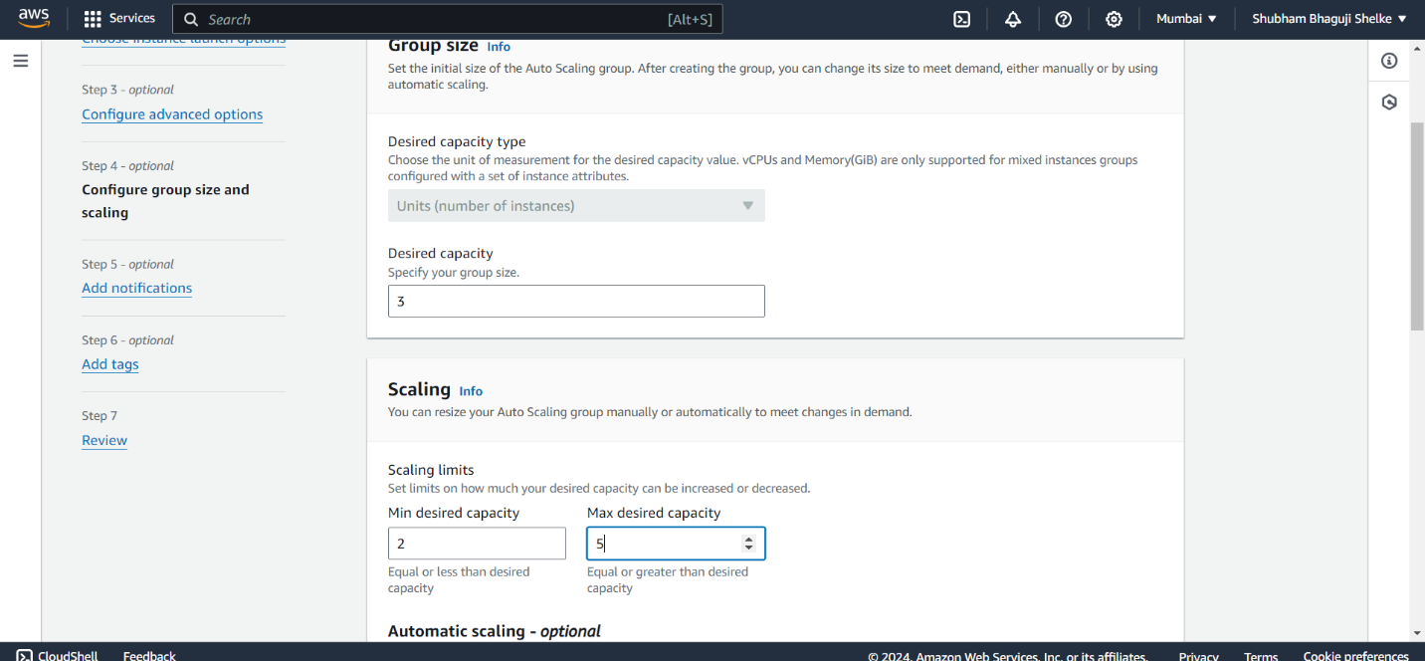

**Add Notification**

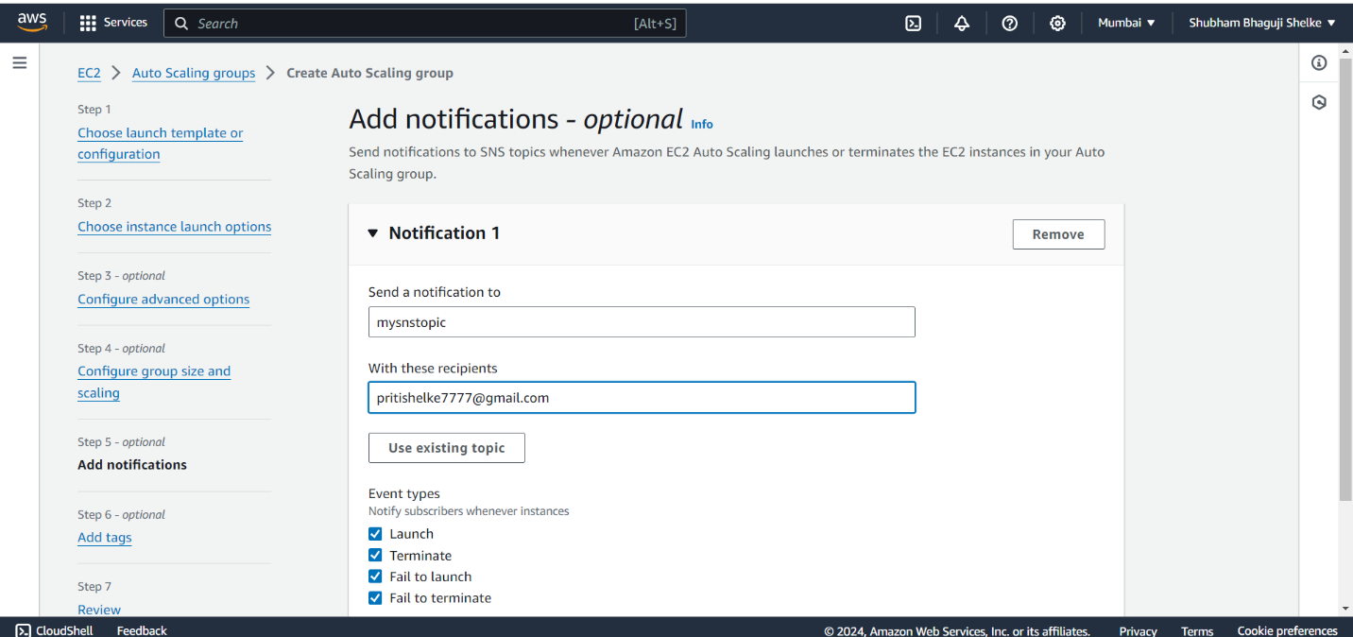

**Create Auto Scaling group**

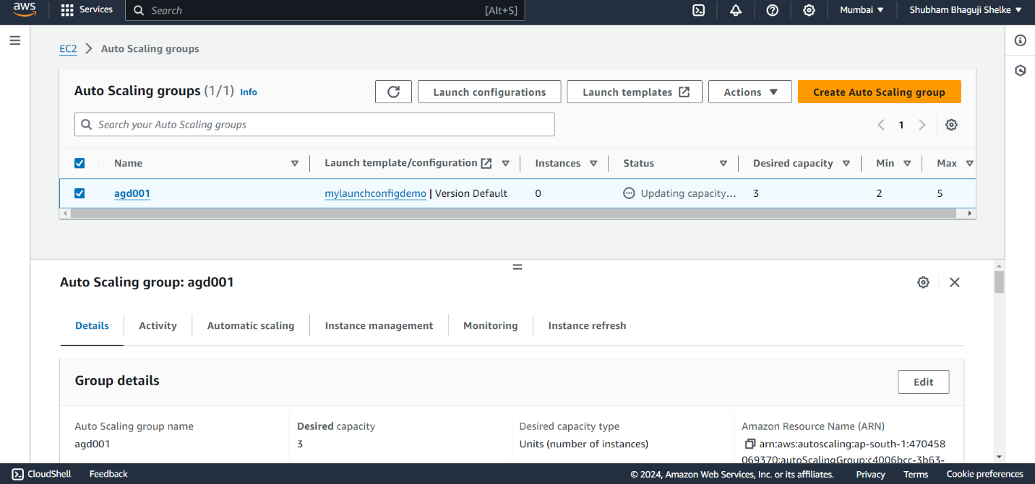

**Instances is create**

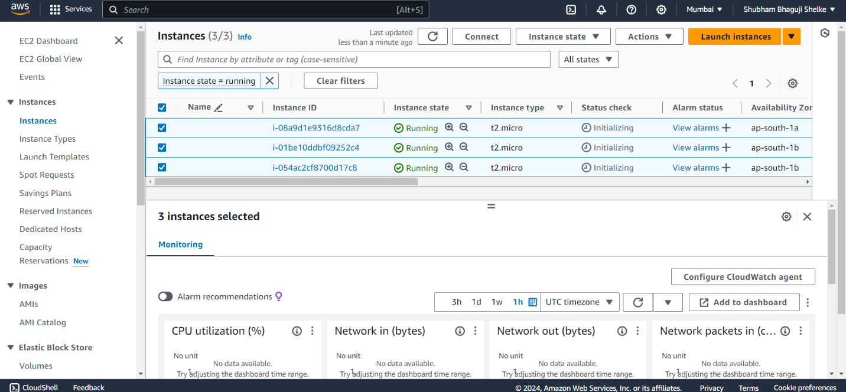

**Create dynamic scaling policy –**

**Create a alarm in (increase_instance_alarm)**

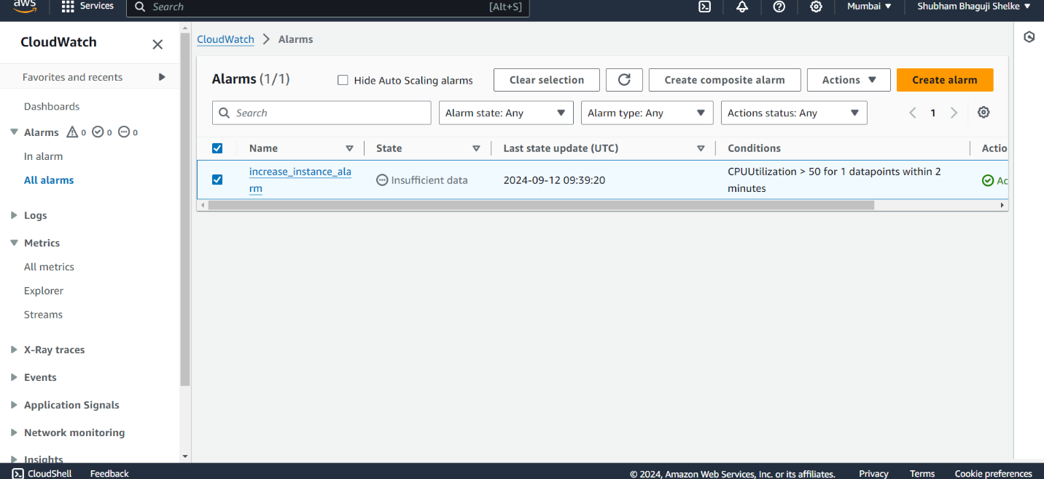

**Increase Dynamic scaling policy –**

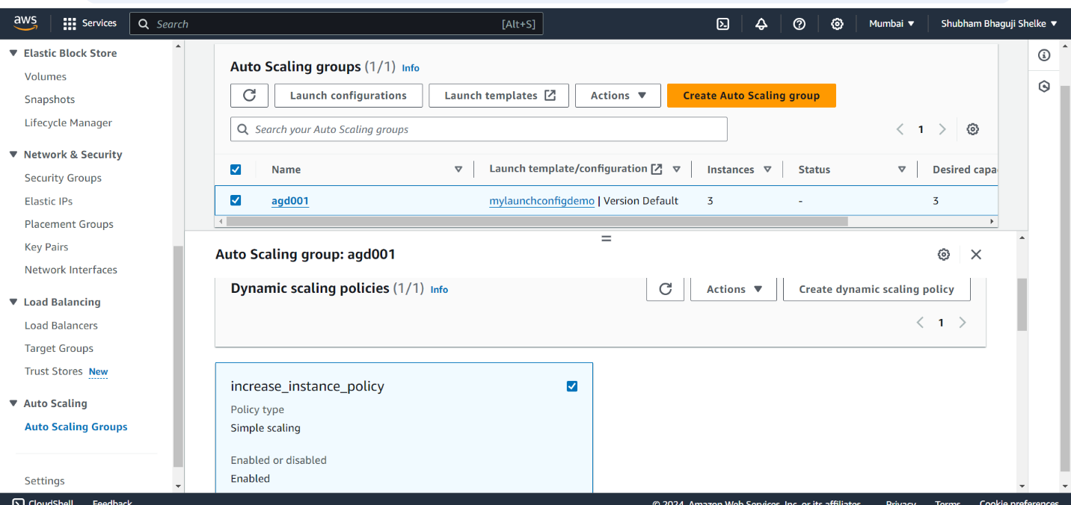

**Create a alarm (decrease_instance_alarm)-**

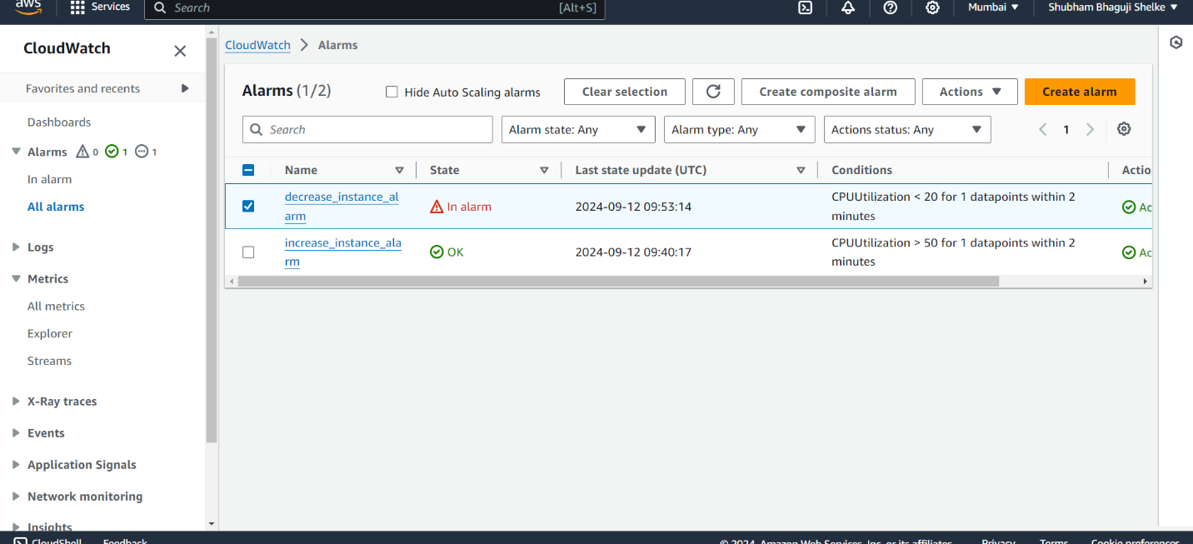

**Decrease Dynamic scaling policy –**

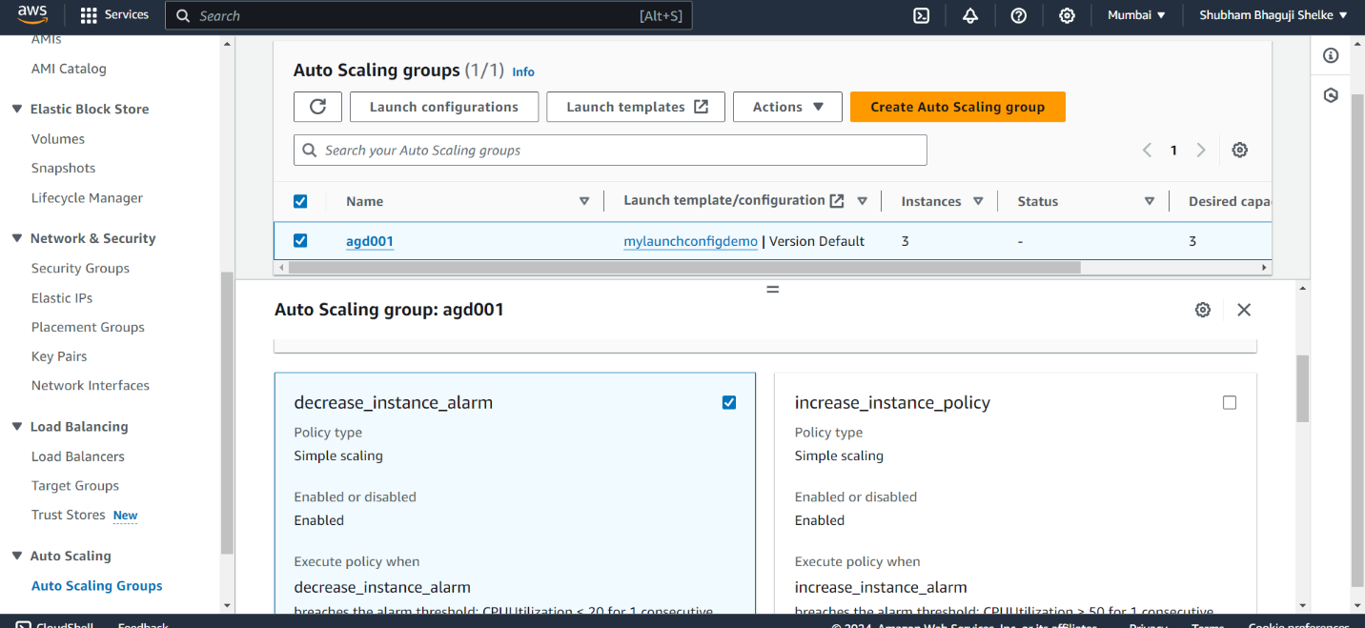

**One remove instance**

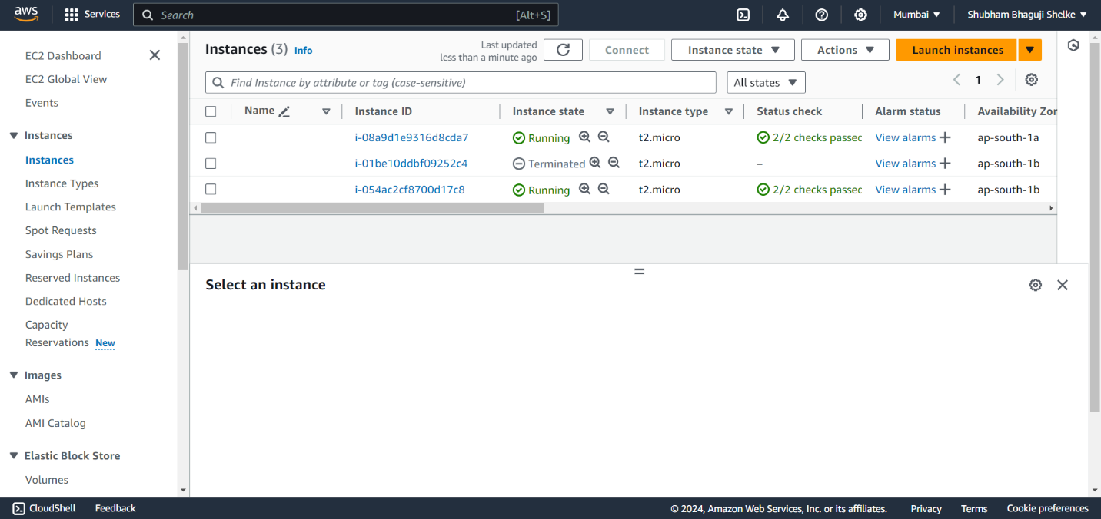

**Load balancing add in Auto scaling group-**

